Wake 1
3-00 PM – 4:00 PM | Viewing /Pianist | 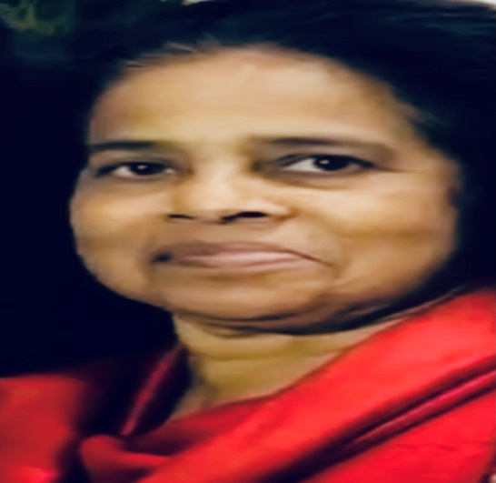
4:00 PM – 5:00 PM | Eulogy
5:00 PM – 6:00 PM | Break
Wake 2
6:00 PM – 6:30 PM | Viewing / Church Choir
6:30 PM - 7:30 PM | Eulogy
7:30 PM – 8:00 PM | Prayer and Service by Rev. David Cherian

Funeral
9:30 AM – 10:00 AM | Viewing /Pianist | 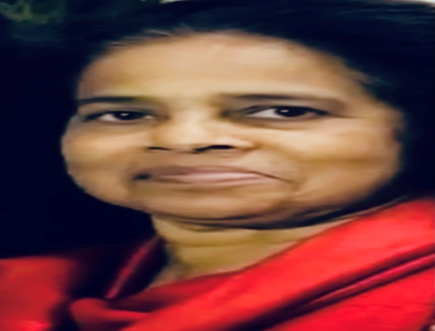
10:00 AM – 11:00 AM | Final Goodbye (Immediate Family)
11:00 AM – 12:00 Noon | Funeral Service by Rev. David Cherian
12:00 Noon – 12:15 PM | Funeral Procession to Burial Site (Our Lady of Peace Cemetery)
12:15 PM – 12:30 PM | Lowering of the Casket
12:30 PM – 1:30 PM | Burial and
1:30 PM – 2:00 PM | Final Respects
2:00 PM – 6:00 PM | Lunch with the Family @ Raja Indian Restaurant

