Gracy’s Wake and Funeral related information
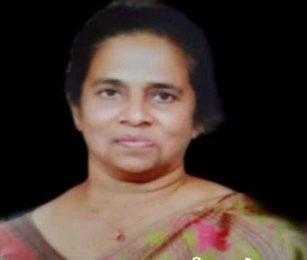
Gracy John (Aleyamma)
Dec 25,1952 – Jan 19,2021

PALM WEST FUNERAL HOME:

Address: 110 Business Parkway, Royal Palm Beach, FL 33411
Tel: 561 753 6004, Email: palmwestfuneralhome.com

Wake Date: Sunday, January 31, 2021

Session Time: (1) 2:00 - 4:00 (2) 6:00 – 8:00

Funeral Date: Monday, February 01, 2021, Time: 9 am – 11:30 ET

CEMETERY: OUR LADY QUEEN OF PEACE CEMETERY

Address: 10941 Southern Blvd, Royal Palm Beach, FL 33411,
Tel: 561 793-7011

Time: 12:00 – 14:30 ET

COVID-19
There is a 50 people restriction inside the funeral home for the wake and 15 people restriction to approach the casket and the burial location. The participants for the funeral service are ncouraged to join the procession to funeral site but remain and watch the proceedings from your car.

After the funeral Ceremony, all participants are kindly requested to join the family for lunch. This premise has outdoor seating and is reserved for the family for this occasion:

Raja Indian Cuisine, 12794 Forest Hill Blvd, Wellington, FL 33414
Tel: 561 581 8368, Website: Rajawellington.com

Webcasting/Zoom Conference of Wake and Funeral Services would be available for remote viewers. Meeting ID/Password will be provided as they become available.

